**Time and space complexity :**

Space complexity is o(n2) because it needs to store similarity matrix.

Time complexity is o(n3) because it takes atmost n iteration to group 2 clusters to form 1 cluster.

And updating similarity matrix takes o(n2) therefore n*n2 = o(n3)

We can reduce time complexity to o(n2lgn) by using mean heap algorithm

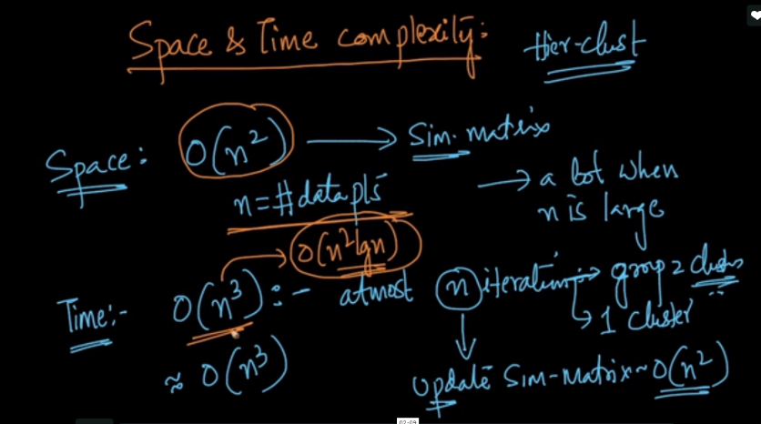

Therefore agglomerative algorithm is not very useful when n is large because if there is 1 million points then it needs 1 TB ram to store it.

